**Demonstrate RESTful with Spring Boot**

**ProductController.java**

package com.test.example;

import java.util.List;

import org.springframework.beans.factory.annotation.Autowired;

import org.springframework.web.bind.annotation.GetMapping;

import org.springframework.web.bind.annotation.PathVariable;

import org.springframework.web.bind.annotation.PostMapping;

import org.springframework.web.bind.annotation.RequestBody;

import org.springframework.web.bind.annotation.RequestMapping;

import org.springframework.web.bind.annotation.RequestMethod;

import org.springframework.web.bind.annotation.RestController;

@RestController

@RequestMapping(path = "/webapi")

public class ProductController {

@Autowired

ProductService productService;

@RequestMapping("/allproduct")

public List<ProductEntity> getAllProduct() {

return productService.getAllProduct();

}

@RequestMapping("/product/{id}")

public ProductEntity getProduct(@PathVariable int id) {

return productService.getProduct(id);

}

@RequestMapping(method = RequestMethod.POST, value = "/product")

public void addProduct(@RequestBody ProductEntity pe) {

productService.addProduct(pe);

}

@RequestMapping(method = RequestMethod.PUT, value = "/product/{id}")

public void updateProduct(@PathVariable int id, @RequestBody ProductEntity pe) {

productService.updateProduct(id, pe);

}

@RequestMapping(method = RequestMethod.DELETE, value = "/product/{id}")

public void deleteProduct(@PathVariable int id) {

productService.deleteProduct(id);

}

}

**ProductEntity.java**

package com.test.example;

import jakarta.persistence.Column;

import jakarta.persistence.Entity;

import jakarta.persistence.GeneratedValue;

import jakarta.persistence.GenerationType;

import jakarta.persistence.Id;

@Entity

public class ProductEntity {

@Id

@GeneratedValue(strategy = GenerationType.AUTO)

@Column(name = "id", updatable = false, nullable = false)

private int id;

@Column

private String name;

@Column

private String description;

public ProductEntity() {

super();

}

public ProductEntity(int id, String name, String description) {

super();

this.id = id;

this.name = name;

this.description = description;

}

public int getId() {

return id;

}

public void setId(int id) {

this.id = id;

}

public String getName() {

return name;

}

public void setName(String name) {

this.name = name;

}

public String getDescription() {

return description;

}

public void setDescription(String description) {

this.description = description;

}

}

**ProductRepository.java**

package com.test.example;

import org.springframework.data.jpa.repository.JpaRepository;

public interface ProductRepository extends JpaRepository<ProductEntity, Integer>{

}

**ProductService.java**

package com.test.example;

import java.util.List;

import org.springframework.beans.factory.annotation.Autowired;

import org.springframework.stereotype.Service;

@Service

public class ProductService {

@Autowired

ProductRepository productRepository;

public List<ProductEntity> getAllProduct(){

return productRepository.findAll();

}

public ProductEntity getProduct(int id){

return productRepository.findById(id).get();

}

public void addProduct(ProductEntity pe){

productRepository.save(pe);

}

public void updateProduct(int id, ProductEntity pe){

if(productRepository.findById(id).isPresent()) {

ProductEntity oldProductEntity=productRepository.findById(id).get();

oldProductEntity.setName(pe.getName());

oldProductEntity.setDescription(pe.getDescription());

productRepository.save(oldProductEntity);

}

}

public void deleteProduct(int id){

productRepository.deleteById(id);

}

public ProductEntity save(ProductEntity productEntity) {

// TODO Auto-generated method stub

return null;

}

}

**RestApiTestApplication.java**

package com.test.example;

import org.springframework.boot.SpringApplication;

import org.springframework.boot.autoconfigure.SpringBootApplication;

import org.springframework.context.annotation.ComponentScan;

import org.springframework.data.jpa.repository.config.EnableJpaRepositories;

@ComponentScan({"com.test.example"})

@EnableJpaRepositories

@SpringBootApplication

public class RestApiTestApplication {

public static void main(String[] args) {

SpringApplication.run(RestApiTestApplication.class, args);

}

}

**Pom.xml**

<?xml version="1.0" encoding="UTF-8"?>

<project xmlns="http://maven.apache.org/POM/4.0.0" xmlns:xsi="http://www.w3.org/2001/XMLSchema-instance"

xsi:schemaLocation="http://maven.apache.org/POM/4.0.0 https://maven.apache.org/xsd/maven-4.0.0.xsd">

<modelVersion>4.0.0</modelVersion>

<parent>

<groupId>org.springframework.boot</groupId>

<artifactId>spring-boot-starter-parent</artifactId>

<version>3.1.0</version>

<relativePath/> <!-- lookup parent from repository -->

</parent>

<groupId>com.test</groupId>

<artifactId>RestApiTest</artifactId>

<version>0.0.1-SNAPSHOT</version>

<name>RestApiTest</name>

<description>Demo project for Spring Boot</description>

<properties>

<java.version>17</java.version>

</properties>

<dependencies>

<dependency>

<groupId>org.springframework.boot</groupId>

<artifactId>spring-boot-starter-data-jpa</artifactId>

</dependency>

<dependency>

<groupId>org.springframework.boot</groupId>

<artifactId>spring-boot-starter-web</artifactId>

</dependency>

<dependency>

<groupId>com.h2database</groupId>

<artifactId>h2</artifactId>

<scope>runtime</scope>

</dependency>

<dependency>

<groupId>org.springframework.boot</groupId>

<artifactId>spring-boot-starter-test</artifactId>

<scope>test</scope>

</dependency>

</dependencies>

<build>

<plugins>

<plugin>

<groupId>org.springframework.boot</groupId>

<artifactId>spring-boot-maven-plugin</artifactId>

</plugin>

</plugins>

</build>

</project>

**OUTPUT**

**List all products 🡪its shows empty, because product is not added.**

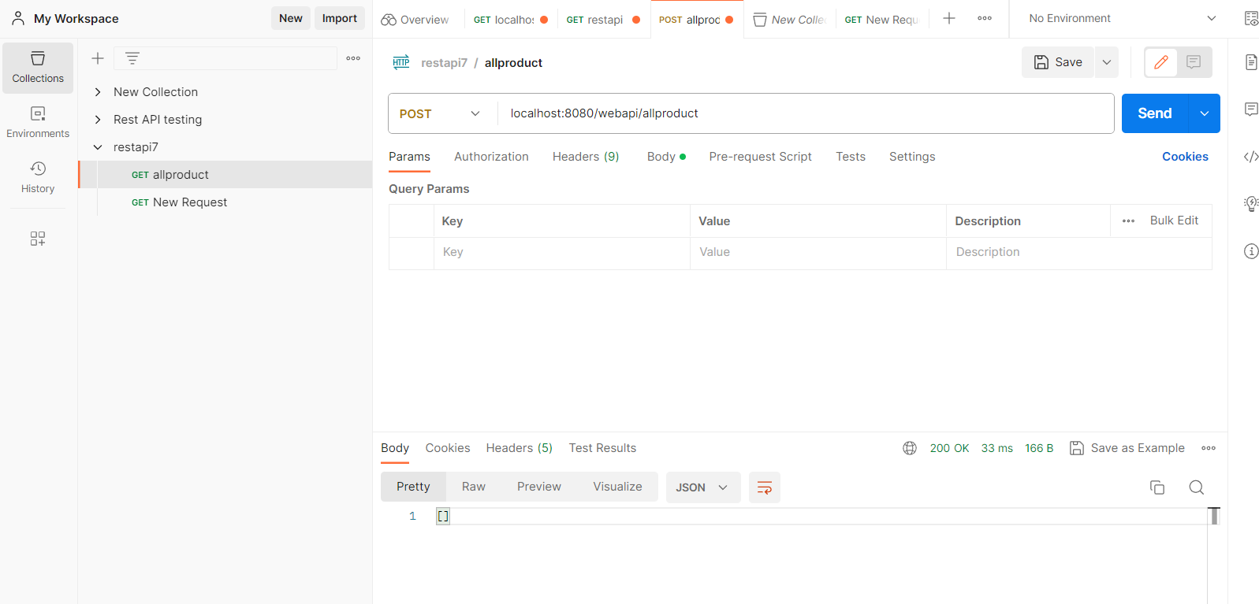

**Adding the products**

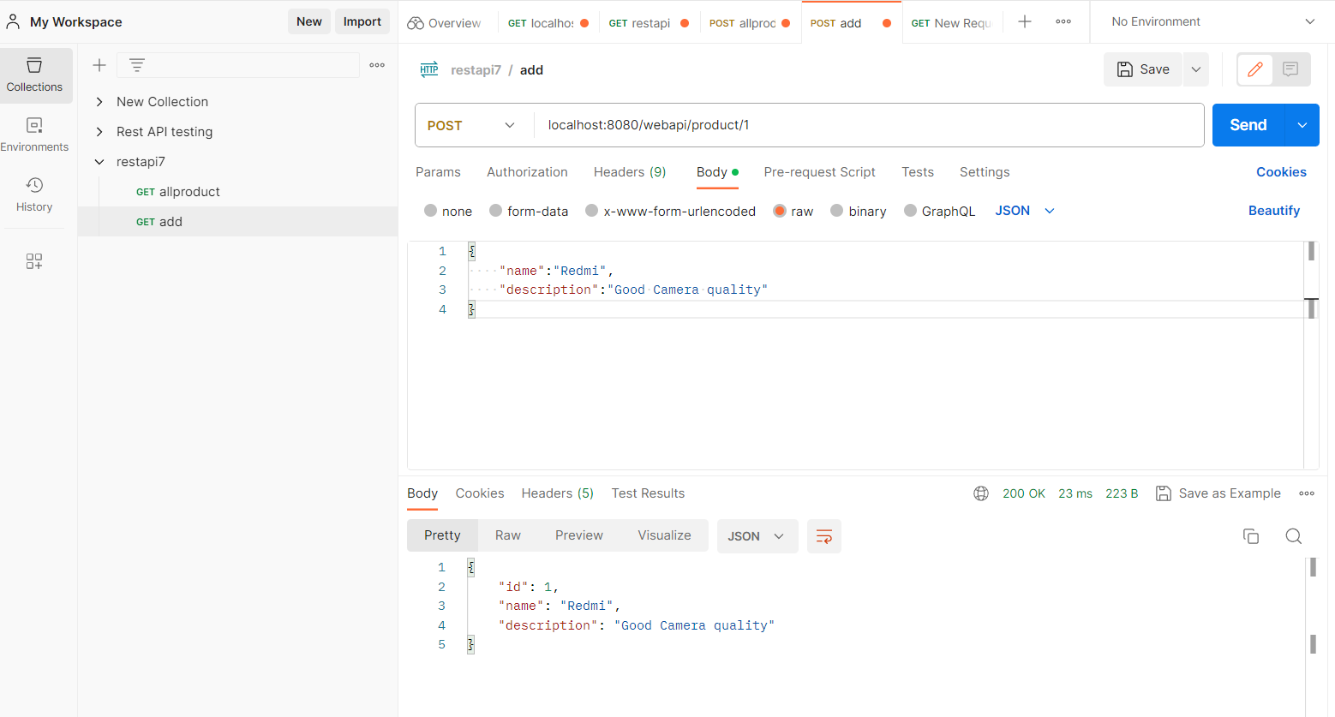

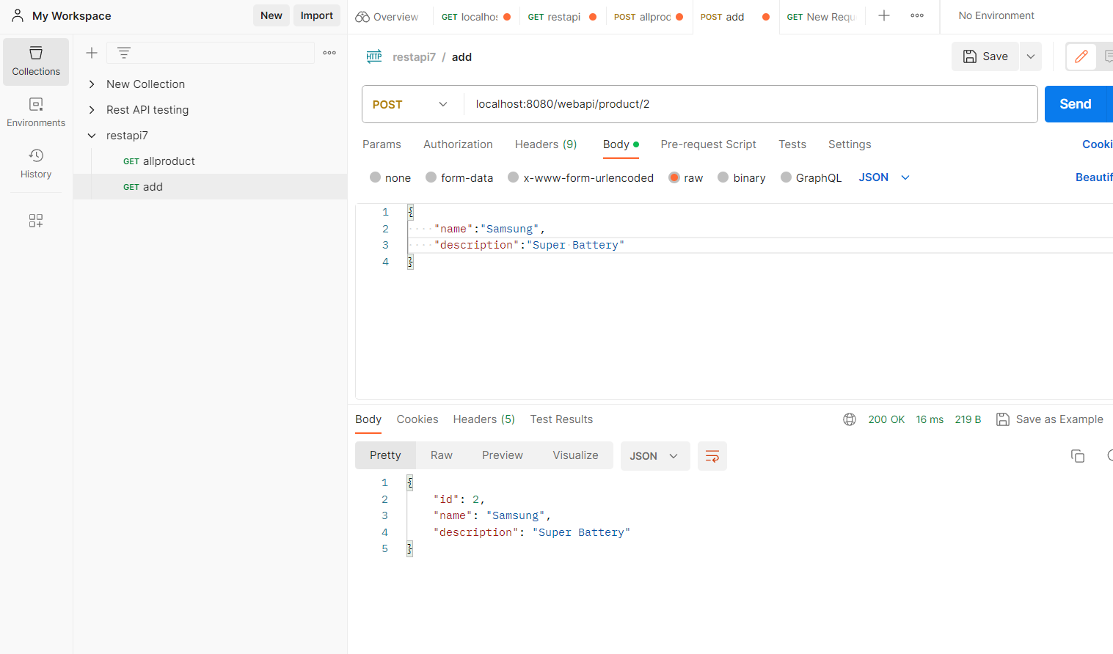

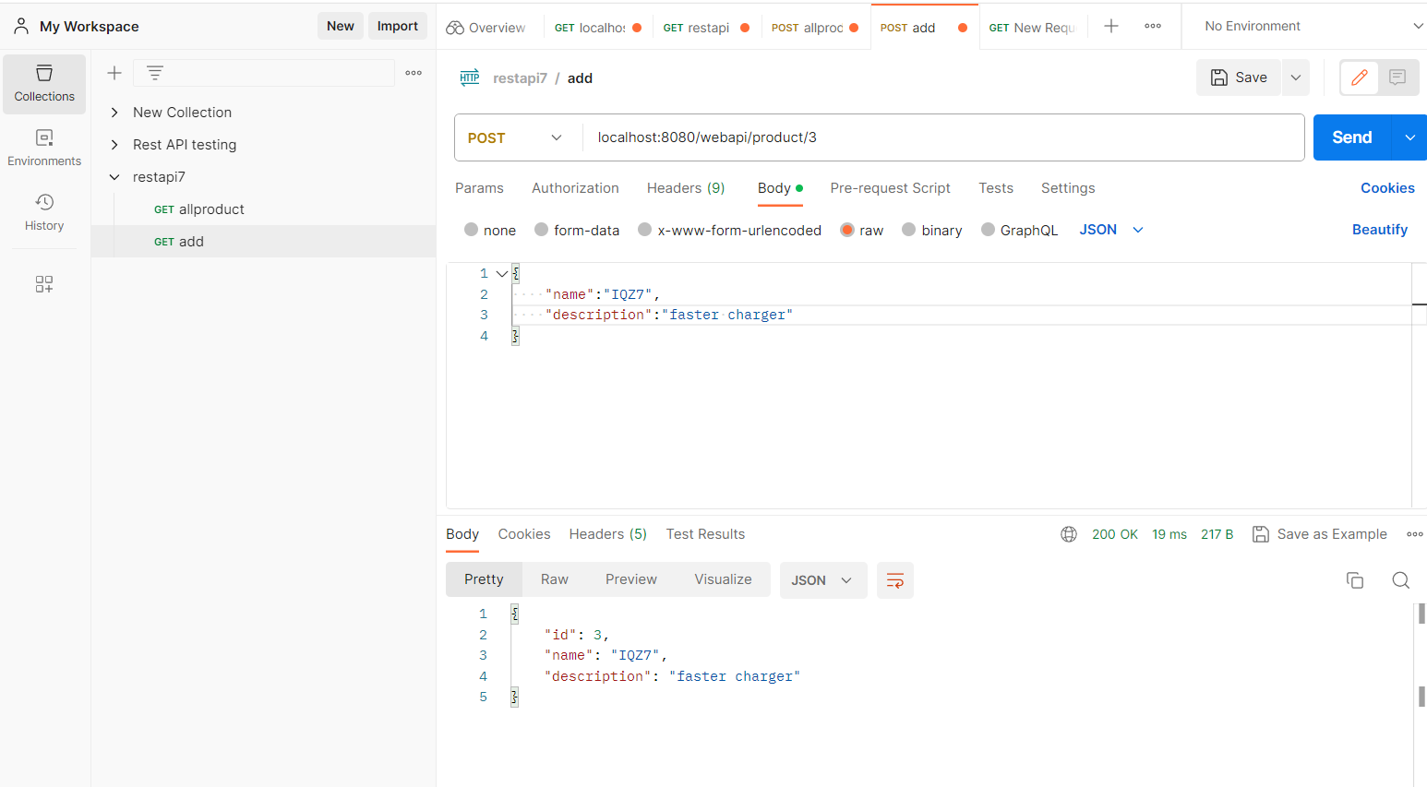

**List all products**

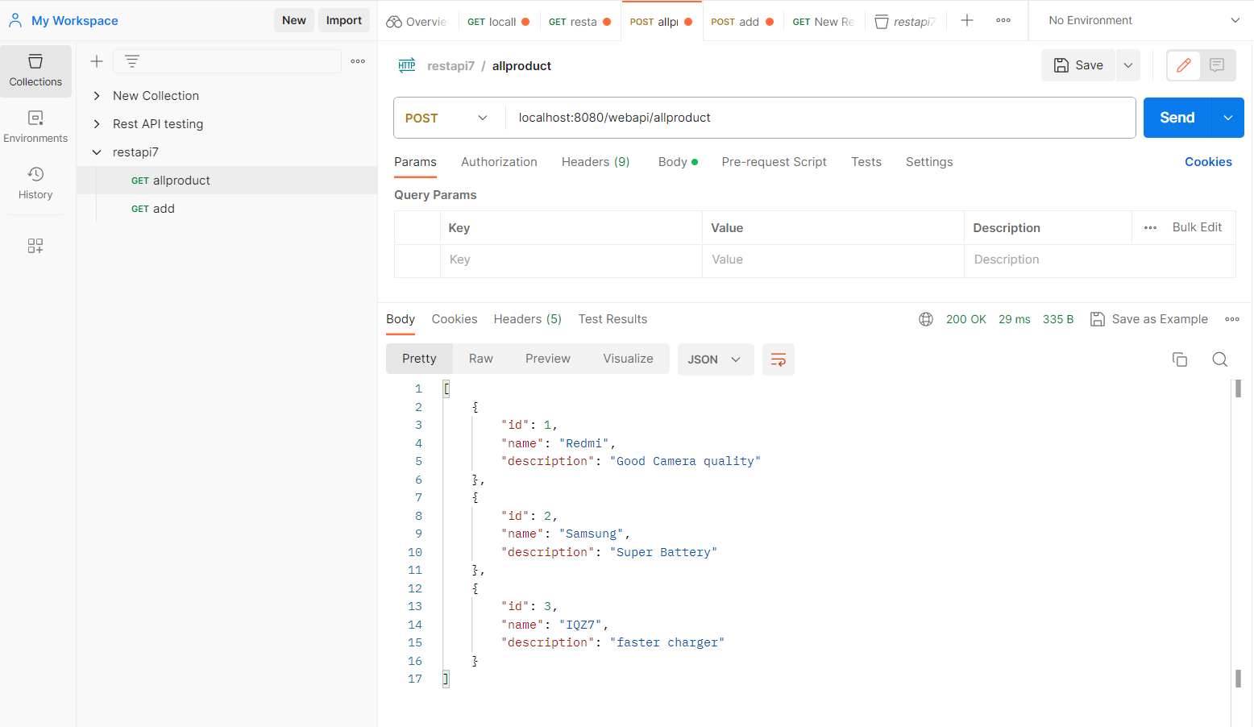

**Update product id 1**

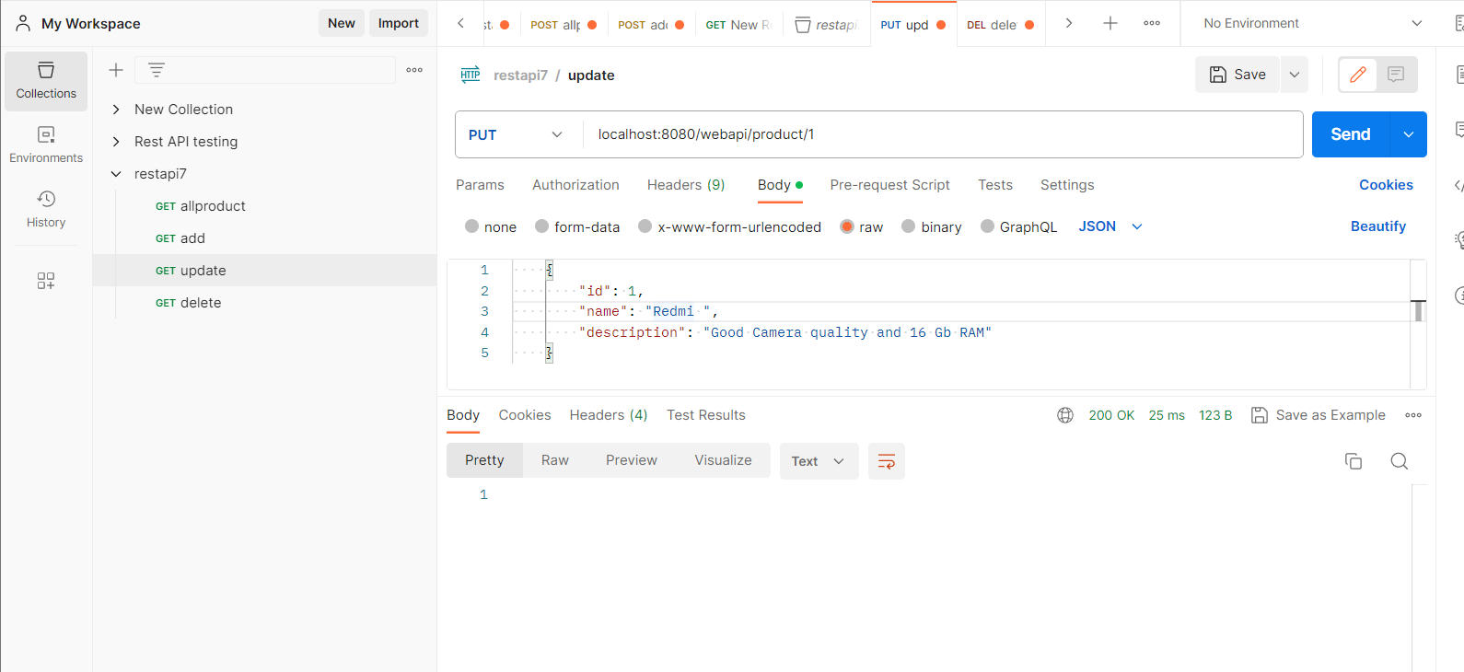

**Now see Updated product 1 in list**

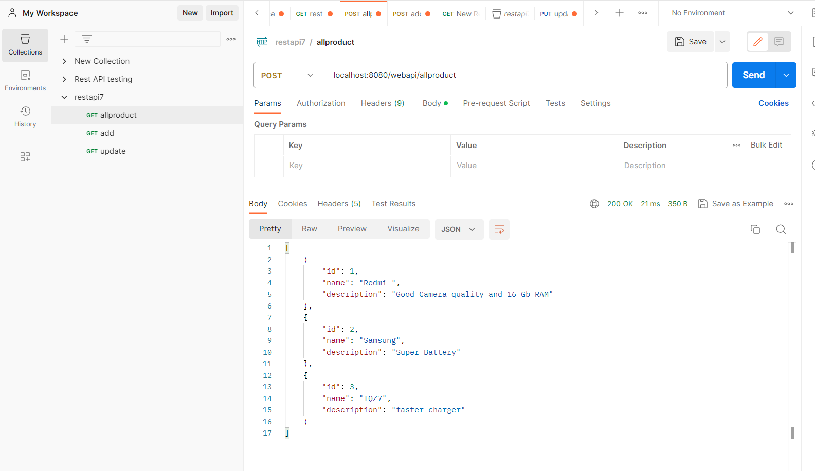

**Delete product 3**

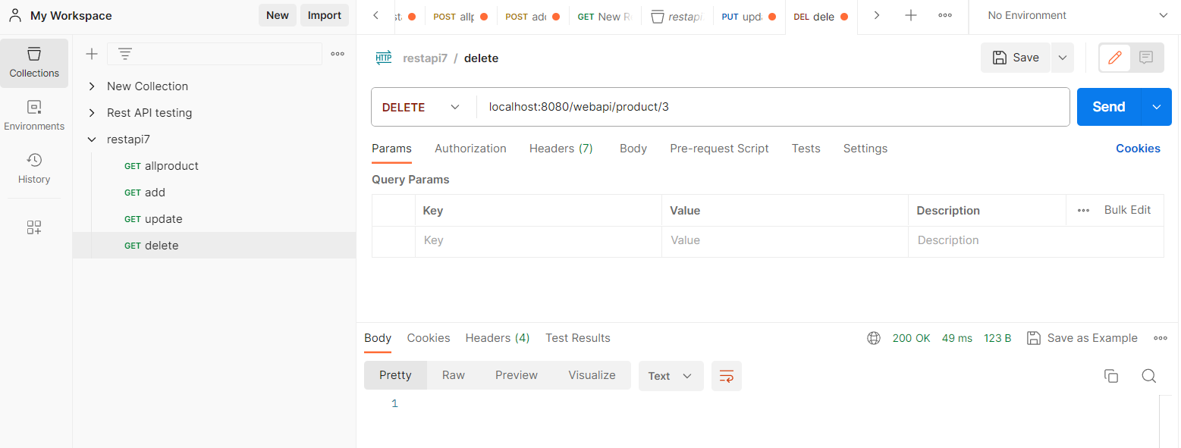

**Product 3 deleted successfully**

